A Supply Chain Analytics Approach to Price Forecasting for Karnataka's TOP Crops: Reducing Oversupply Risk Through Data-Driven Farm Planning
Interim Report
Alvis Lazarus A
Walsh College
QM640: Data Analytics Capstone
Pralhad Teggi
Term 3
August 4, 2026

Introduction, Scope, and Objectives

Background and Context
Onion, tomato, and potato -- referred to throughout this report as Karnataka's “TOP crops” -- are among the state's most heavily traded and most price-volatile horticultural commodities, moving through the Agricultural Produce Market Committee (APMC) mandi network. Unlike Minimum Support Price (MSP)-backed cereal staples, these three crops are perishable and largely outside MSP protection, which leaves growers fully exposed to short-run supply and demand shocks. A single month of oversupply can erase a season's margin, and no widely available tool currently converts a price forecast into a concrete, farm-level planting decision for these crops in Karnataka specifically.
The modelling approach adopted in this report is grounded directly in the literature reviewed in the next section. Sable et al. (2024) benchmarked fourteen algorithms on five years of Mumbai APMC price data and found XGBoost the strongest performer (R² = 0.972), and Dharavath and Khosla (2019) validated seasonal ARIMA specifically on Bengaluru, Karnataka price data. This is the reason the present project pairs an XGBoost model against a SARIMA baseline rather than a more exotic alternative; both choices are grounded in prior work on data that closely resembles the data used here, rather than chosen for novelty.

Problem Statement
Karnataka's TOP-crop growers remain exposed to price volatility and recurring oversupply cycles because no existing, published tool converts a price forecast into an actionable, farm-level planting decision for this specific crop set and geography. Price-forecasting work such as Sable et al. (2024) predicts mandi prices accurately but stops short of a profit figure a farmer could act on. Crop-recommendation work such as Sam and D'Abreo (2025) and Dwibedy et al. (2026) does incorporate economic variables, but at a multi-state or single-market resolution too coarse to reflect Karnataka's district-level mandi and rainfall patterns. No published study forecasts onion, tomato, and potato for Karnataka as a grouped set, benchmarks that forecast against naive and SARIMA baselines under a validation protocol that avoids look-ahead leakage, and converts the result into a profit-ranked, uncertainty-aware recommendation. This is the gap the present project addresses.

Purpose of the Study
The purpose of this study is fourfold. First, it predicts monthly wholesale (modal) mandi prices for onion, tomato, and potato across four of Karnataka's major producing districts using an XGBoost regression model, benchmarked against a seasonal-naive baseline and a SARIMA baseline. Second, it explains which agronomic, temporal, and economic features -- rainfall, seasonality, lagged price, and cost of cultivation -- drive those forecasts, and tests whether Sam and D'Abreo's (2025) finding that economic variables outrank environmental ones replicates in this price-forecasting context. Third, it ranks crop-month combinations by expected profit, combining the price forecast with district-level cost-of-cultivation data, rather than stopping at the price forecast alone. Fourth, it quantifies forecast uncertainty through prediction intervals, so that any farmer-facing output reports a defensible range instead of a false-precision point estimate.

Scope and Objectives
The scope of this study is bounded to three commodities (onion, tomato, potato), four major Karnataka markets (Kolar, Chikkaballapur, Bengaluru, and Hassan) rather than a statewide sweep, and monthly-aggregated mandi price data drawn from government sources, evaluated under rolling-origin (walk-forward) validation to avoid the information-leakage failure mode that both Sable et al. (2024) and Sam and D'Abreo (2025) had to correct for in their own work.
Four research questions define the analytical boundaries of the project. The statistical technique used to answer each one is presented in the Modelling section; this section states what is being asked.

Research Question 1 (RQ1)
To what extent does an XGBoost regression model outperform a naive (seasonal-persistence) baseline and a SARIMA baseline in forecasting monthly modal mandi prices of onion, tomato, and potato across the four pilot districts, as measured by mean absolute percentage error (MAPE) and root mean squared error (RMSE), under rolling-origin (time-respecting) cross-validation?

Research Question 2 (RQ2)
Among lagged price, monthly rainfall, seasonal/calendar indicators, and district-level cost of cultivation, which features contribute most to the XGBoost model's price predictions, and does the resulting importance ranking replicate Sam and D'Abreo's (2025) finding that economic variables outrank environmental ones?

Research Question 3 (RQ3)
Does a profit-ranking model that combines XGBoost price forecasts with cost-of-cultivation data identify crop-month combinations with significantly higher expected returns than a price-only ranking?

Research Question 4 (RQ4)
Do prediction intervals generated from the XGBoost forecast via a native quantile-regression objective achieve empirical coverage closer to nominal confidence levels (80% and 95%) than intervals derived from the SARIMA baseline?

What “Interim” Means for This Report
This is the interim submission, not the final capstone report. Every pipeline stage described below -- cleaning, feature engineering, baselines, the XGBoost model, and the four hypothesis tests -- was executed end-to-end on the real source data described in the Data Description section, and every number reported in this document is drawn directly from that executed run rather than estimated or assumed. What is not yet final is hyperparameter tuning depth (the project timeline budgets two full weeks to this in Phase 4; the results below use a fixed, reasonable configuration rather than an exhaustive search) and the profit-ranking analysis for tomato, which is carried through cleaning and price forecasting but held out of RQ3 until its cost-of-cultivation figure is sourced, as explained in the Data Description section. Results are therefore reported throughout as preliminary, consistent with the Preliminary Results section of this report.

Literature Survey
The literature review below summarizes the studies this project builds on most directly, what each one found, and -- more importantly -- what it did not do, since those gaps motivate the design choices made in this report. Table 1 presents the comparison.
Table 1
Comparison of Key Studies Informing This Project's Design
Study | Focus | Key Finding | Gap Relative to This Project
Sable et al. (2024) | 14 ML algorithms on 5 years of Mumbai APMC prices | XGBoost strongest fit (R² = 0.972); flagged their own earlier validation as leaky | Forecasts price only; no profit conversion, no farm-level action
Dharavath & Khosla (2019) | Seasonal ARIMA on fruit/vegetable prices, including Bengaluru, Karnataka | SARIMA is a credible baseline specifically for Karnataka produce prices | Single-crop, single-model; no machine learning comparison
Paul et al. (2022); Tran et al. (2023) | ML for agricultural price forecasting (brinjal/Odisha; systematic review) | Gradient boosting is now the field's default for tabular price forecasting | Review of 27 papers found no study groups related commodities together
Sam & D'Abreo (2025) | Crop recommendation combining environmental and economic variables | Economic variables outrank environmental ones in their models | Multi-state resolution, too coarse for Karnataka's district-level patterns; crop choice, not price forecast
Dwibedy et al. (2026) | Kisan AI, a profit-aware crop advisory system | Coined “economic blindness” for advisory tools that ignore price | Folds price into the advisory output but does not report forecast accuracy separately
Doshi et al. (2018); Kiran et al. (2024); Motamedi et al. (2023); Senapaty et al. (2024) | Crop-recommendation systems (SVM, ANN, Random Forest) | Solid agronomic-suitability classifiers | All optimize for agronomic fit; price is an afterthought or omitted
Synthesis. Three threads converge on the same open problem. First, gradient boosting -- specifically XGBoost -- is repeatedly the strongest price-forecasting model in this domain, which is why it is the primary model used here rather than a neural or classical alternative. Second, the crop-recommendation literature (Sam & D'Abreo, 2025; Dwibedy et al., 2026) shows economic variables matter for guidance systems, but neither study operates at Karnataka's district level, and neither separately reports forecast accuracy. Third, and most directly, Tran et al.'s (2023) systematic review found that of 27 screened papers -- with India already the single most-studied country for this question -- not one groups related commodities into a single pipeline. Framing onion, tomato, and potato as one grouped, profit-aware pipeline for Karnataka answers that specific, named gap rather than a generic one.
A second, methodological thread runs through this literature and shapes the validation protocol used throughout this report: both Sable et al. (2024) and Sam and D'Abreo (2025) independently reported an information-leakage problem in their own initial validation setup -- a suspiciously perfect R² in one case, random-shuffle cross-validation in the other -- and had to correct for it. Every walk-forward split used in this report is built specifically to avoid that failure mode, so that training data always precedes the test month it predicts and is never mixed randomly with it.

Distinction From Existing Work
This distinction is stated explicitly here, rather than left implicit in the literature comparison above, since a synthesis paragraph alone can understate exactly how this project's contribution differs from prior work. Table 1 already shows what each prior study did; the four points below state, plainly, what none of them did together and what this project does instead.
- Sable et al. (2024) forecasts price accurately but stops at the forecast. This project takes that same forecast and converts it into a profit figure (RQ3), a step Sable et al. does not attempt.
- Sam and D'Abreo (2025) and Dwibedy et al. (2026) incorporate economic variables into crop guidance, but at a multi-state or single-market resolution. This project operates at Karnataka's district level (four confirmed pilot districts) using district-specific rainfall and market prices, a finer resolution than either study, and separately reports forecast accuracy, which Dwibedy et al.'s Kisan AI system does not.
- Tran et al. (2023) found that no reviewed study, out of 27 screened, groups related commodities into one pipeline. This project forecasts onion, tomato, and potato as one grouped, profit-aware pipeline rather than three independent single-crop studies, directly closing that named gap.
- No reviewed study benchmarks its forecast against both a naive and a SARIMA baseline under rolling-origin validation, converts the result into a profit ranking, and separately quantifies prediction-interval coverage. This project does all four (RQ1-RQ4) in one pipeline on the same four-district panel, which is the specific, compound contribution this synopsis-stage gap statement was asked to make more explicit.

Data Description
Four government and research sources feed this project. All four are read directly from the raw files at the time this pipeline runs; nothing in this report is manually re-typed from a source table. Table 2 lists each source, its coverage, and its access point.
Table 2
Raw Data Sources Used in This Project
Source | Coverage | URL
AGMARKNET (Market-wise Report) | Daily market/commodity wholesale prices, 2019-2026, Karnataka | agmarknet.gov.in/marketwisespecificcommodityinput
NASA POWER | Daily district-level rainfall, 2016-2026, Karnataka districts | power.larc.nasa.gov
Agricultural Statistics at a Glance 2023 | Annual district-level area, production, and yield | desagri.gov.in (Agricultural Statistics at a Glance 2023)
DES Cost of Cultivation Scheme | Annual state-level cultivation cost per hectare (onion, potato only) | desagri.gov.in (Cost of Cultivation Scheme)
Tomato's cost of cultivation is not part of the DES series, which covers onion and potato only. Vanitha et al. (2018)'s Kolar-district tomato survey was identified as the intended source for that figure, but the survey does not publish a single per-hectare cost number in the same format as the DES rows, so it cannot be merged in as a clean value. Rather than inventing a number, tomato is carried through cleaning, exploratory analysis, and price forecasting exactly like onion and potato, and is excluded only from the RQ3 profit-ranking step, as documented in the Preliminary Results section.

Dataset Quality Assessment
Before any cleaning action is taken, each raw source was assessed on its own terms for completeness, internal consistency, likely bias, and its missing-value pattern, so that the cleaning decisions documented in the Analysis section respond to a diagnosed problem rather than a generic checklist. Table 3 summarizes this assessment; the narrative that follows highlights the two findings with the largest downstream consequence.
Table 3
Dataset Quality Assessment by Raw Source
Source | Completeness | Consistency | Potential Bias | Missing-Value Pattern
Mandi price (AGMARKNET) | 98,228 raw rows, 2019-07-15 to 2026-07-15, no null values in any column | 14 exact-duplicate rows and 8 internally inconsistent rows (modal price outside its own min/max) found on inspection | Markets self-report to APMC; larger, more active yards likely over-represented relative to smaller rural markets | No missing cells in the raw extract; gaps instead take the form of entire calendar months with zero reported transactions for a given market-commodity pair
Rainfall (NASA POWER) | 61,408 raw rows, 2016-01-01 to 2026-07-04, no null values | Internally consistent; single authoritative satellite-derived source, no duplicate-record risk | Each district is represented by one satellite grid cell, a spatial proxy for, not a direct measurement of, rainfall across a whole district | None in the raw extract; full daily coverage for every source district
Yield, area, and production (Agricultural Statistics at a Glance 2023) | 1,534 raw rows spanning agricultural years 1998-1999 through 2024-2025 | Internally consistent; production and area jointly imply yield, which matches the reported yield column on spot checks | Statewide district list is uneven in reporting history; some districts have longer back-series than others | After filtering to the four pilot districts and three crops, several district-crop-year combinations are absent (see Data Cleaning), addressed by carrying the nearest available year's figure forward
Cost of cultivation (DES Cost of Cultivation Scheme) | Only 8 raw rows total: onion for 2017-2018 through 2021-2022, potato for 2017-2018 through 2019-2020 | Internally consistent (operational plus fixed cost sums to the reported total in every row) but the sparsest of the four sources by a wide margin | State-level only, no district column, so all four pilot districts necessarily share one cost figure per crop-year | No tomato row exists at all; coverage also stops at 2021-2022, short of the mandi price panel's 2026 endpoint
Two findings from Table 3 carry the most weight later in this report. First, the cost-of-cultivation source is markedly thinner than the other three: eight rows total, state-level rather than district-level, and silent on tomato entirely. This single limitation is the direct cause of two decisions made elsewhere in this report: the RQ3 profit formula uses one Karnataka-wide cost figure for all four districts (Modelling section), and tomato is excluded from RQ3 until a usable figure is sourced (Preliminary Results section). Second, rainfall's grid-cell representation is a spatial proxy rather than a district-wide measurement; this is carried forward as a named limitation rather than presented as ground-truth district rainfall, and is revisited in the Limitations and Reliability discussion.

District Selection
Kolar and Chikkaballapur (the tomato and onion belt, and the site of the Vanitha et al. (2018) cost-of-cultivation survey), Bengaluru, and Hassan (historically Karnataka's largest potato district) were chosen over a full statewide sweep to keep data cleaning tractable within a ten-week project, since cleaning effort scales with the number of districts included. Four markets with confirmed reporting coverage across all three crops represent a more tractable and honest scope than a sixteen-district plan with unverified coverage.

Repository and Reproducibility
The raw and cleaned data, collection scripts, and modelling code for this project are versioned in a public GitHub repository at github.com/learnandgrow072025/capstone_project_alvis, organized into Data, Program, and Output folders, satisfying this template's reproducibility requirement. The analysis notebook accompanying this report reads the four raw source files directly through this same folder structure (via a mounted Google Drive copy or a direct upload), so the full pipeline documented below is independently re-runnable rather than a one-time, manually assembled result. Figure 1 shows the repository as it stands: the three top-level folders described above, a populated commit history documenting incremental development rather than a single end-of-project push, and a root-level README.md that documents the repository's structure, setup steps, and how to reproduce the pipeline end to end, so the “with instructions” expectation for a working repository is satisfied by the repository itself rather than by this report's description of it.
Figure 1
capstone_project_alvis repository on GitHub (public), showing the Data, Output, and Program folders, commit history, and README.
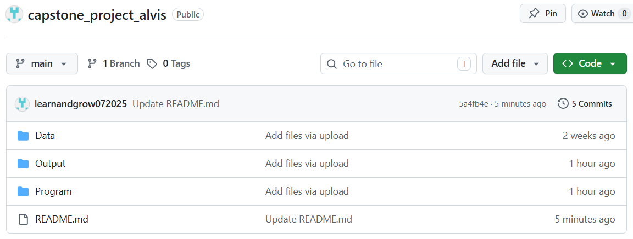

Data Dictionary
The dictionary below is grounded directly in the structure of the four confirmed source extracts, organized by source file. Type, unit, meaning, and relevance are given for every variable exactly as it appears in the raw extract; variables constructed during feature engineering are listed in their own table at the end, in the same format, rather than described only in prose.
Table 4
Data Dictionary: Mandi (Wholesale) Price, Market-wise Report
Variable | Type | Unit | Meaning | Relevance
Date | Date | Daily (YYYY-MM-DD in source) | Calendar date of the reported wholesale transaction | Aggregated to monthly modal price; the time axis for RQ1's forecast
State | Categorical | - | State name (Karnataka throughout this extract) | Confirms geographic scope; constant, not a model feature
District/Market | Categorical | 73 APMC markets in source | APMC market/yard name (e.g., “Bengaluru APMC”, “Hassan APMC”); source column is literally named “district/market” | Filtered to the markets covering the four pilot districts (Kolar, Chikkaballapur, Bengaluru, Hassan)
Commodity | Categorical (3 levels) | - | Crop type: Onion, Tomato, or Potato | Defines the three parallel forecasting problems
Variety | Categorical (17 levels in source) | - | Sub-type/grade reported at that market (e.g., Local, Potato, Other) | Not currently used as a model feature; retained for a possible future stratification check
Modal Price | Continuous | Rs./quintal | Most frequently traded wholesale price for that date/market/commodity | Primary dependent variable for RQ1 (aggregated to a monthly series)
Min Price / Max Price | Continuous | Rs./quintal | Reported low/high wholesale price for the same observation | Supports volatility/range checks; not a primary predictor
Arrival Quantity | Continuous | Metric tonnes | Quantity of the commodity arriving at the market that day | Not in the current RQ2 predictor set; flagged as a candidate supply-side feature for later iterations
Table 5
Data Dictionary: Rainfall, NASA POWER District Extract
Variable | Type | Unit | Meaning | Relevance
date | Date | Daily (YYYY-MM-DD) | Calendar date of the rainfall reading | Aggregated to a monthly total before merging onto the price panel
district | Categorical (16 districts in source) | - | Karnataka district name | Join key onto the price panel's district field
grid_lat / grid_lon | Continuous | Decimal degrees | Latitude/longitude of the single NASA POWER grid cell used to represent that district | Traceability of the rainfall figure to its source grid cell; not a model feature itself
precipitation_mm | Continuous | mm/day | Daily rainfall total at the district's grid cell | Environmental predictor for RQ2 (aggregated to monthly mm)
Table 6
Data Dictionary: Yield, Area, and Production, Agricultural Statistics at a Glance 2023
Variable | Type | Unit | Meaning | Relevance
Year | Categorical/ordinal | Agricultural year (e.g., “2021 - 2022”) | Cropping year the figures refer to | Annual grain; mapped onto the monthly panel as a constant-within-year covariate
District | Categorical (33 values incl. state total) | - | Karnataka district (source also includes an “All Districts” state-level row) | Join key onto the price panel's district field
crop | Categorical (3 levels) | - | Onion, Tomato, or Potato | Join key onto the price panel's commodity field
area_hectares | Continuous | Hectares | District-level area under cultivation for that crop-year | Context for the yield figure used in the profit calculation
production_tonnes | Continuous | Tonnes | District-level total production for that crop-year | Cross-check for yield (production ÷ area)
yield_tonnes_per_hectare | Continuous | Tonnes/hectare | District-level average yield for that crop-year | Yield multiplier in the RQ3 profit formula (forecast price × yield − cost)
Table 7
Data Dictionary: Cost of Cultivation, DES Cost of Cultivation Scheme
Variable | Type | Unit | Meaning | Relevance
year | Categorical/ordinal | Fiscal year (e.g., “2021-2022”) | Year the cost figures refer to | Annual grain; mapped onto the monthly panel as a constant-within-year covariate
state | Categorical | - | “Karnataka” or “All-India” - state-level only in the confirmed extract, no district field | See state-vs-district note below; limits RQ3's stated district-level cost precision
crop | Categorical (2 levels in source) | - | Onion or Potato only; the DES series does not cover tomato | Tomato cost of cultivation is instead sourced from Vanitha et al. (2018)'s Kolar-district survey, as already noted in this synopsis
operational_cost_rs_per_ha | Continuous | Rs./hectare | Variable input costs (seed, labor, fertilizer, irrigation, etc.) | Component of total cultivation cost
fixed_cost_rs_per_ha | Continuous | Rs./hectare | Fixed costs (land rent/value, depreciation, etc.) | Component of total cultivation cost
total_cost_rs_per_ha | Continuous (derived: operational + fixed) | Rs./hectare | Total per-hectare cultivation cost | Cost term in the RQ3 profit formula
Two variables are engineered rather than drawn directly from a source file: lag1_price, the previous month's modal price for the same crop-district series, and season, a Kharif (June-October), Rabi (November-February), or Summer (March-May) label derived from calendar month. Table 8 documents both in the same format as the four raw-source dictionaries above, rather than in prose alone, so every predictor used anywhere in this report, raw or engineered, has a matching dictionary entry.
Table 8
Data Dictionary: Derived Variables (Engineered, Not Raw Source Columns)
Variable | Type | Unit | Meaning | Relevance
lag1_price | Continuous | Rs./quintal | Previous month's modal price for the same crop-district series | Engineered predictor for RQ1, RQ2, RQ4
season | Categorical (3 levels) | — | Kharif / Rabi / Summer, derived from calendar month | Engineered predictor for RQ1, RQ2, RQ4
Both derived variables are engineered predictors used in RQ1, RQ2, and RQ4, as named in the Research Question to Data and Method Alignment table in the Modelling section. The Analysis section documents a fuller extended feature set (additional lags, rolling statistics, and calendar features) built on top of these two core variables, as well as the sample size required to support this feature set for each research question.
Two variables considered earlier were deliberately excluded from the model. Minimum Support Price (MSP) is not applicable, since onion, tomato, and potato are not MSP-notified crops; carrying an MSP variable over from studies of MSP-eligible crops would be a factual error. A Hassan potato “regime-break” dummy, marking the district's roughly 2006-2007 acreage collapse (Deccan Herald, 2026), was also considered, but the four-year price window used here begins around 2019, entirely after that collapse, so the dummy would be constant across the whole sample and unusable as a predictor.

Analysis

Data Cleaning
Cleaning was executed in a fixed, logged order so that every count reported below is auditable rather than asserted. The five subsections that follow map directly onto that pipeline: how missing values were handled, how outliers and duplicates were treated, the preprocessing steps themselves, the reasoning behind each method chosen, and how the workflow was kept reproducible end to end.

Handling Missing Values
Two distinct kinds of missingness appear in this panel, and each was handled on its own terms rather than with a single blanket rule. First, some district-crop series have calendar gap months where the APMC reported nothing at all. Because lag-1 price and the seasonal-naive baseline both depend on true calendar spacing, each series was reindexed onto its own continuous month range, first reported month to last, before any feature was built; a gap month becomes a real row with a missing price rather than silently vanishing and shifting what “last month” means for the row after it. This inserted 42 gap-month rows across the panel, shown in Table 9 below.
Second, the annual yield and cost-of-cultivation figures do not cover every district-crop-year combination in this window: the DES cost series stops at 2021-2022, yield has isolated gaps, and tomato has no DES cost row at all. Rather than drop those rows, the last known annual figure was carried forward, and the earliest known figure carried backward for years before a series starts, within each district-crop series. This fully populated the yield figures (382 missing values reduced to zero) and left only the tomato cost-of-cultivation gap unresolved (339 rows), which is the DES coverage limitation already identified in the Data Description section rather than a defect in the carry-forward method.

Outliers and Duplicates
Fourteen exact-duplicate rows in the raw mandi extract, the same market, commodity, and date record pulled twice, were dropped before any aggregation, so the monthly mean price does not quietly double-count a transaction. A further eight rows failed basic internal consistency, reporting a modal price outside their own minimum/maximum range or a minimum that exceeded the maximum outright; these are data-entry errors in the source rather than real price behavior, and were dropped rather than averaged in.
Statistical outliers on price were then flagged using two independent methods: a Tukey interquartile-range (IQR) fence and a modified Z-score based on the median absolute deviation, applied per district-crop series. The two methods flagged 42 and 34 rows respectively, agreeing on 31 of them, a reasonable overlap given that they rest on different statistical assumptions. Critically, these flagged rows were kept, not removed, a decision explained further below.

Clear Preprocessing Steps
The pipeline runs in the same fixed order every time it is executed: (1) drop exact duplicate rows in the raw mandi extract; (2) drop rows that fail basic internal consistency; (3) standardize district and market naming across all four sources onto one set of labels; (4) aggregate daily price and rainfall to monthly figures; (5) insert gap months so lag features respect true calendar spacing; (6) carry annual yield and cost figures forward onto the monthly panel; (7) flag statistical outliers by two independent methods without removing them; and (8) build the extended lag, rolling, and calendar feature set described under Reproducible Workflow below. Table 9 reports the count produced at each of these steps from the executed pipeline.
Table 9
Data Cleaning Log From the Executed Pipeline
Cleaning Step | Count
Duplicate rows dropped (exact duplicates in raw mandi extract) | 14
Internally inconsistent price rows dropped (modal price outside its own min/max range) | 8
Rows retained after filtering to the four pilot districts, mandi price | 18,246 of 98,206
Rows retained after filtering to the four pilot districts, rainfall | 15,352 of 61,408
Rows retained after filtering to the four pilot districts, yield/area | 243 of 1,534
Monthly price rows after aggregation | 952
Monthly rainfall rows after aggregation | 508
Gap months inserted as missing (calendar spacing preserved) | 42
Statistical price outliers flagged, IQR method (kept, not removed) | 42
Statistical price outliers flagged, modified Z-score method (kept, not removed) | 34
Rows flagged by both outlier methods | 31
Final panel size (district × crop × month) | 994
Step 3 required one genuine correction: Bengaluru's tomato trade is recorded under a separate “Binny Mill (F&V), Bengaluru APMC” market yard rather than the main “Bengaluru APMC” yard used for onion and potato. Both were confirmed, by checking commodity counts per market name in the raw extract, to belong to the same district's APMC network and were folded into a single “Bengaluru” label before monthly aggregation.

Justification for Methods Used
- Carry-forward (not interpolation) for annual covariates: yield and cost of cultivation are step-function figures that hold constant for an entire agricultural year, so linearly interpolating between two annual values would fabricate a smooth trend that does not exist in the underlying data. Carrying the last known figure forward is the more honest treatment of a genuinely step-shaped variable.
- Flag, not remove, for statistical outliers: onion's 2019-2020 supply-shock spike, visible in Figure 2 below, is exactly the kind of real volatility this project forecasts. Removing statistically extreme rows would bias the model toward a calmer market than the one that actually exists, so outliers are retained and only flagged for downstream awareness.
- Two independent outlier methods rather than one: IQR and modified Z-score rest on different assumptions about the underlying distribution (quartile-based versus median-absolute-deviation-based), so agreement between them is stronger evidence than either method alone, and disagreement is informative about which rows are borderline.
- Calendar-true reindexing before feature engineering: lag and rolling features are only meaningful if “last month” genuinely means one calendar month earlier. Reindexing each series onto its own continuous month range before computing any lag avoids silently compressing a gap month out of the lag structure.

Reproducible Workflow
The cleaning pipeline is deterministic and independently re-runnable: it reads the four raw source files directly (see Data Description), executes the eight steps above in the same fixed order every time, and a fixed random seed governs every stochastic step used later in modelling, so the same source files reproduce the same cleaned panel, the same walk-forward folds, and the same results. The code is versioned in the project's public GitHub repository alongside the raw and cleaned data, satisfying this template's reproducibility requirement directly rather than by description alone.
Built on top of this same reproducible pipeline, three additional feature families were constructed beyond the lag-1 price and season indicator used for RQ1 and RQ2: a longer lag structure (t-1, t-3, t-6, and t-12), rolling three- and six-month mean and standard-deviation statistics computed only from past values, using a one-month shift before rolling so the current month can never leak into its own feature, and calendar features (month and quarter) alongside the existing season label. The RQ2 model itself deliberately retains the four-feature set (lag-1 price, rainfall, season, cost of cultivation) sized by the sample size computation later in this section, rather than silently expanding the feature count past what that computation justified; the extended set is available for the tuning phase of the final report.

Exploratory Data Analysis (EDA)

Appropriate Statistical Summaries and Visualizations
Table 10 summarizes the modal price distribution by crop across the cleaned panel, and Table 11 summarizes reporting completeness by district-crop series.
Table 10
Modal Price Summary Statistics by Crop (Rs./quintal)
Crop | n | Mean | SD | Min | 25th %ile | Median | 75th %ile | Max
Onion | 295 | 2,205.1 | 1,226.1 | 752.3 | 1,399.0 | 1,900.0 | 2,691.7 | 11,003.4
Potato | 326 | 1,769.7 | 563.5 | 732.6 | 1,352.5 | 1,741.5 | 2,074.4 | 4,325.0
Tomato | 331 | 1,758.0 | 1,241.3 | 315.7 | 1,006.0 | 1,400.0 | 1,994.1 | 8,904.3
Table 11
Reporting Completeness by District-Crop Series
District | Crop | Months in Span | Months Reported | % Reported
Kolar | Onion | 60 | 52 | 86.7
Bengaluru | Potato | 85 | 77 | 90.6
Hassan | Tomato | 85 | 78 | 91.8
Bengaluru | Onion | 85 | 78 | 91.8
Hassan | Potato | 85 | 80 | 94.1
Hassan | Onion | 85 | 81 | 95.3
Chikkaballapur | Tomato | 84 | 83 | 98.8
Chikkaballapur | Onion | 85 | 84 | 98.8
Chikkaballapur | Potato | 85 | 84 | 98.8
Bengaluru | Tomato | 85 | 85 | 100.0
Kolar | Potato | 85 | 85 | 100.0
Kolar | Tomato | 85 | 85 | 100.0
Figure 2
Monthly modal price by district, shown separately for onion, tomato, and potato.
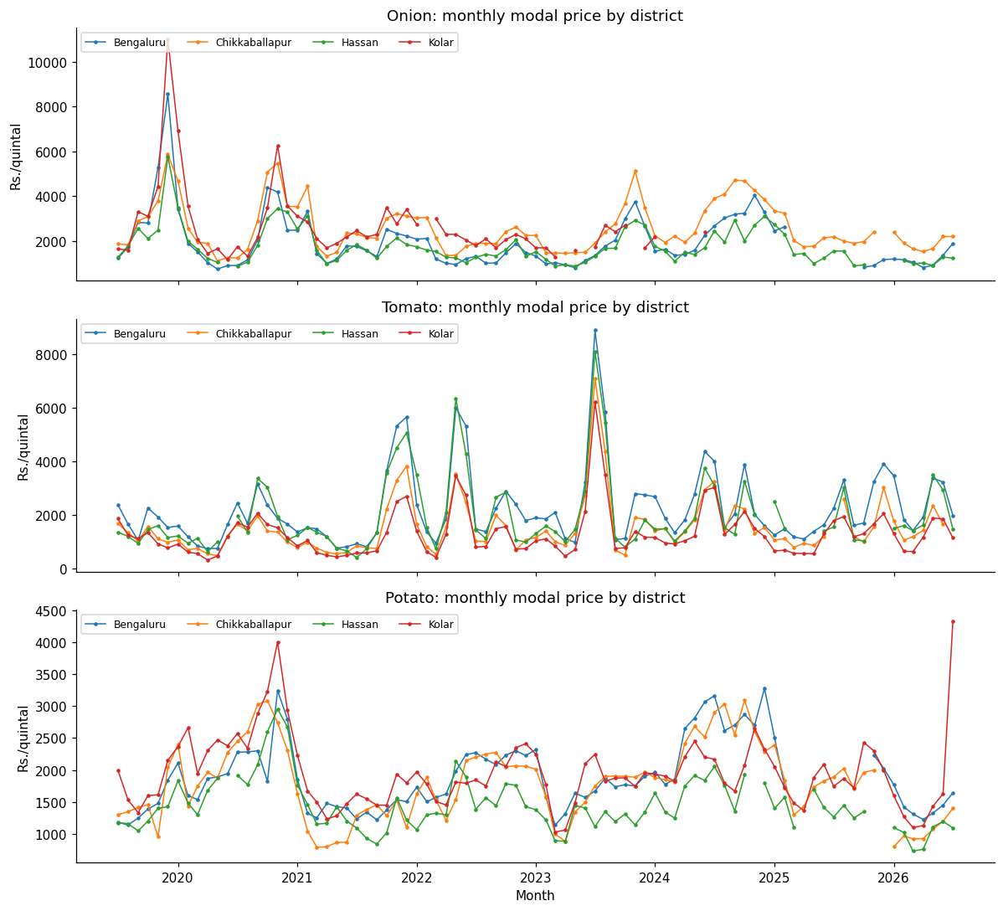
Figure 3
Modal price distribution by crop and season (Kharif, Rabi, Summer).
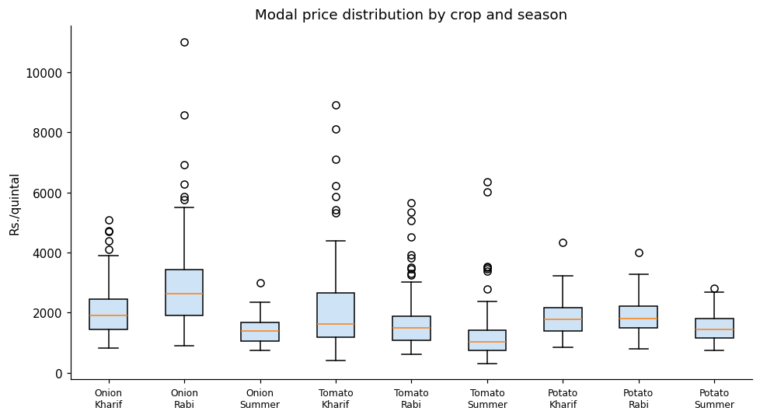
Figure 4
Correlation matrix of key numeric variables, pooled across all district-crop series.
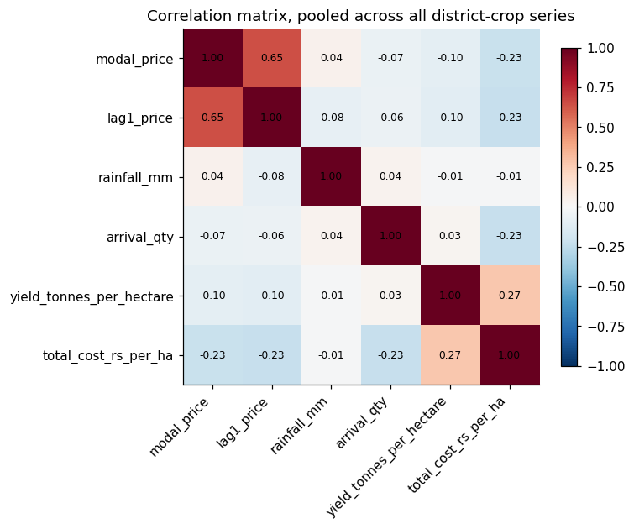
Figure 5
Monthly rainfall versus modal price, by crop, pooled across districts.
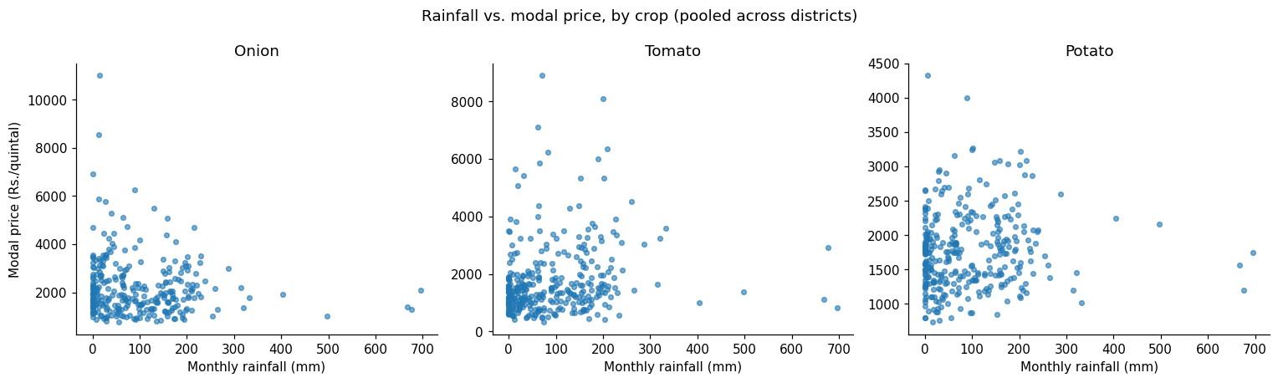
Kolar tomato was used for a formal seasonal decomposition, shown in Figure 6, because it is one of only three series with no reporting gaps, allowing classical decomposition, which requires a complete and evenly spaced series, to run without first interpolating missing months.
Figure 6
Additive seasonal decomposition of the Kolar tomato modal price series (period = 12 months).
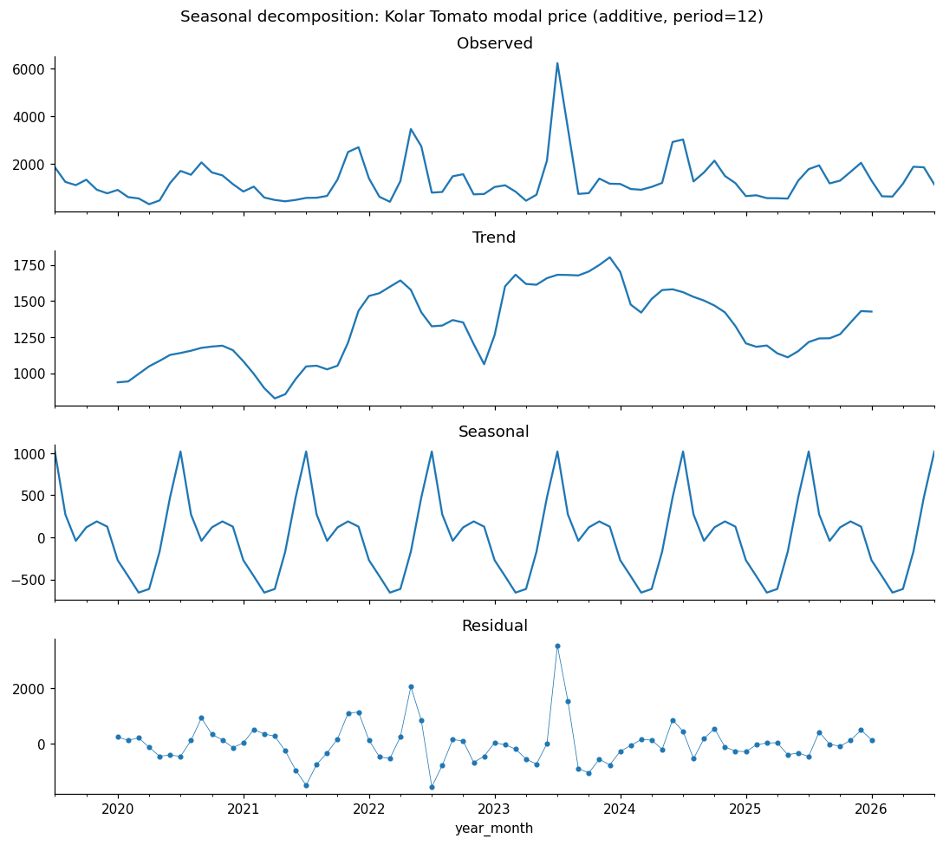
The decomposition's seasonal component swings by approximately Rs. 1,674 per quintal peak to trough, while the residual component's standard deviation is approximately Rs. 736 per quintal and the trend component ranges by approximately Rs. 975 per quintal over the series.

Identifies Patterns, Trends, and Anomalies
- Onion is by far the most volatile of the three crops (Table 10: SD of 1,226.1 versus 563.5 for potato), with a maximum of Rs. 11,003.4 per quintal driven by the 2019-2020 supply-shock spike visible in Figure 2, consistent with the exposure to short-run supply shocks discussed in the Introduction.
- Seasonality is present but crop-specific: potato's distribution in Figure 3 shifts far less across Kharif, Rabi, and Summer than onion's does, consistent with potato being a more storable, less perishable crop whose price is smoothed by stock-holding, while onion and tomato show sharper seasonal separation.
- Rainfall's relationship with price is weak and noisy at the monthly, pooled level (Figure 5; correlation matrix in Figure 4), suggesting rainfall is more likely a lagged or district-specific driver than a same-month one.
- Reporting coverage is an anomaly worth naming on its own: Kolar's onion series (Table 11) stops entirely in mid-2024 and reports only 86.7% of its shorter span before that, while every other series reports 90% or higher.
- The seasonal-decomposition residual (Figure 6) is not small relative to the seasonal component itself, roughly 44% of the seasonal swing, indicating that trend and seasonality alone leave real structure in the series unexplained.

Supports Research Questions
Each pattern identified above feeds directly into a later analytical choice, not as a general observation but as the specific reason a specific feature, model, or validation choice was made in the Modelling section. Lag-1 price's strong correlation with current price (Figure 4) is the reason it is included as a predictor for RQ1, RQ2, and RQ4 in the Research Question to Data and Method Alignment table in the Modelling section, and the reason RQ1 benchmarks XGBoost against a seasonal-naive baseline using a twelve-month lag rather than a random or mean baseline, so the bar the model must clear is genuinely informative. Rainfall's weak pairwise correlation is exactly why it is retained as a feature for RQ2 rather than dropped: a weak linear correlation is not evidence of low importance to a nonlinear model, so the question is settled by RQ2's permutation-importance analysis in the Preliminary Results section rather than assumed from Figure 4 or Figure 5 alone. The seasonal-decomposition residual's size is direct evidence that a simple seasonal or trend-following model leaves real structure on the table, motivating the choice of a feature-driven model such as XGBoost over a classical alternative for RQ1, as argued in the Model Selection subsection. Finally, the coverage gaps documented in Table 11, particularly Kolar onion's, are carried forward explicitly as a scope constraint on how far the RQ1-RQ4 conclusions can be generalized, and are revisited in the Limitations and Reliability subsection rather than smoothed over.

Sample Size Computation (per RQ)
Because each research question has a different statistical design, a single sample-size rule does not fit all four; the subsections below state which method applies to each, the exact parameters used, the resulting requirement, and a check that the requirement is internally consistent with the modelling choices made elsewhere in this report.

Correct Method (Power/CI)
- RQ1 and RQ2 (regression-style questions): Green's (1991) rule for multiple regression, an overall-model heuristic requiring N ≥ 50 + 8m, where m is the number of predictors.
- RQ3 (paired comparison of two ranking methods): an a-priori power analysis for a paired-samples t-test, which sizes the sample needed to detect a specified effect size at a given significance level and power.
- RQ4 (coverage-rate estimation): a confidence-interval-based sample size for a proportion, since RQ4's outcome is the fraction of prediction intervals that contain the true value, a proportion rather than a mean difference.
RQ2 specifically uses Green's overall-model variant rather than the stricter individual-predictor variant (N ≥ 104 + m): the individual-predictor variant tests ordinary-least-squares coefficient significance, and XGBoost, a tree ensemble, does not produce per-predictor p-values the way ordinary least squares does, so the overall-model variant is the more methodologically honest fit for this model choice.

Parameters Stated
- RQ1: m = 3 predictors (lag-1 price, season indicator, district rainfall); α = .05.
- RQ2: m = 4 predictors (lag-1 price, season, rainfall, cost of cultivation); α = .05.
- RQ3: α = .05 (two-tailed), power = .80, d = 0.50 (medium effect size; Cohen, 1988).
- RQ4: Z = 1.96 (corresponding to 95% confidence), p = 0.5 (most conservative assumption for an unknown proportion), margin of error e = 0.10.

Sample Size Computed for Each RQ
Applying each method with the parameters above produces the minimum sample size shown in Table 12 for each research question.
Table 12
Minimum Sample Size by Research Question
RQ | Method | Key Parameters | Minimum N
RQ1 | Green's rule, overall model / R² test | N ≥ 50 + 8m; m = 3 (lag-1 price, season, rainfall); α = .05 | 74
RQ2 | Green's rule, overall model / R² test | N ≥ 50 + 8m; m = 4 (+ cost of cultivation); α = .05 | 82
RQ3 | A-priori power analysis, paired-samples t-test | α = .05 (two-tailed), power = .80, d = 0.50 (medium; Cohen, 1988) | 32
RQ4 | CI-based proportion (coverage-rate estimation) | Z = 1.96 (95% CI), p = 0.5, margin = 0.10 | 97
The overall required sample size is N = max(74, 82, 32, 97) = 97, driven by RQ4's coverage-rate requirement rather than either regression question.

Logical Consistency
Three consistency checks tie this computation to the rest of the report rather than leaving it as an isolated calculation. First, each RQ's m in Table 12 matches, term for term, the fields listed for that RQ in the Research Question to Data and Method Alignment table in the Modelling section: RQ1's m = 3 is lag-1 price, season, and rainfall; RQ2's m = 4 adds cost of cultivation, the same four fields that table lists as RQ2's inputs. The sample-size computation and the feature set actually used are therefore the same object described twice, not two independently maintained lists that could drift apart. Second, RQ4's proportion-based requirement (N = 97) is the binding constraint precisely because it is evaluated per held-out prediction, not per model fit, and rolling-origin validation accumulates one evaluation point per time step per district-crop series, so the requirement is expected to be cleared by pooling folds across the twelve-series panel rather than from a single train/test split. Third, and more directly, the executed pipeline reported in the Preliminary Results section produced between 262 and 310 walk-forward evaluation rows depending on the specific test, comfortably exceeding N = 97 across all four research questions; the sample-size computation was therefore not just a synopsis-stage formality but a target the executed analysis actually met.

Insights and Interpretation
- Onion is by far the most volatile of the three crops. Its boxplots in Figure 3 span a much wider range than tomato or potato in every season, and the price trend lines in Figure 2 show sharp, multi-thousand-rupee swings within a single season, most visibly the 2019-2020 spike. This matches the Background and Context discussion of onion's exposure to short-run supply shocks and is the reason statistical outliers were flagged rather than removed during cleaning.
- Seasonality is real but crop-specific. Potato's distribution shifts far less across Kharif, Rabi, and Summer than onion's does, consistent with potato being a more storable, less perishable crop whose price is smoothed by stock-holding, while onion and tomato, both more perishable, show sharper seasonal separation.
- Rainfall's relationship with price is weak and noisy at the monthly, pooled level. The scatter plots in Figure 5 show no strong linear pattern for any of the three crops, and the correlation matrix in Figure 4 confirms this. This does not mean rainfall is irrelevant; it is more likely a lagged or district-specific driver than a same-month one, which is exactly the kind of relationship a tree-based model such as XGBoost can capture even when a simple pairwise correlation misses it, as tested formally in the RQ2 permutation-importance analysis in the Preliminary Results section.
- Lag-1 price is, unsurprisingly, the strongest linear correlate of the current month's price across all three crops, motivating the comparison of XGBoost against a seasonal-naive baseline that uses a twelve-month lag rather than a random or mean baseline: the bar the model has to clear is a genuinely informative one, not a strawman.
- Reporting coverage is uneven across series, as shown in Table 11. Most district-crop combinations report 90 to 100% of their own calendar span, but Kolar's onion series stops entirely in mid-2024 and reports only about 87% of its shorter span before that. This is carried forward as a named limitation rather than patched over with a longer synthetic series.
- The seasonal-decomposition residual is not small relative to the seasonal component itself. A large leftover-noise term after both trend and seasonality are removed is further, formal evidence that a simple seasonal or trend-following model leaves real structure on the table for a feature-driven model to capture.

Modelling

Research Question to Data and Method Alignment
How each research question connects to the dataset's actual fields, and why the chosen method, rather than an alternative, fits that question, is answered directly in Table 13 before the subsections below elaborate on each column: which raw fields feed each analysis, which model or statistical method is applied, and the reasoning for that specific pairing.
Table 13
Research Question to Dataset Fields and Method Mapping
RQ | Dataset Fields Used (Source) | Model / Method | Why This Method Fits This RQ
RQ1 | modal_price (target, Mandi Price); lag1_price (derived); rainfall_mm (Rainfall); season (derived); district, crop (Mandi Price) | XGBoost regression vs. seasonal-naive vs. SARIMA, all under walk-forward validation | XGBoost captures nonlinear, cross-feature relationships neither baseline can; naive sets a zero-cost floor a real system must clear; SARIMA is a classical bar validated specifically on Karnataka produce prices by Dharavath and Khosla (2019)
RQ2 | Same four predictors as RQ1, with total_cost_rs_per_ha (Cost of Cultivation) added | Permutation importance computed on the trained RQ1 XGBoost model | XGBoost is a tree ensemble and produces no per-predictor p-value the way ordinary least squares does; permutation importance is a model-agnostic technique that ranks contribution without requiring a second, differently-specified model
RQ3 | xgb_pred (RQ1 model output); yield_tonnes_per_hectare (Yield/Area/Production); total_cost_rs_per_ha (Cost of Cultivation) | Profit formula (forecast price × yield × 10 − cost) per crop-district-month; paired-samples comparison of realized returns, profit-ranked vs. price-only-ranked selection | Directly operationalizes “does adding cost and yield to the ranking beat price alone,” and a paired test is the correct design because the same set of months is scored under two ranking rules rather than two independent samples
RQ4 | Same predictors as RQ1/RQ2; price re-expressed at the 0.10/0.90 and 0.025/0.975 quantiles | XGBoost's native quantile-regression objective vs. SARIMA's parametric confidence intervals; PICP with a one-sample binomial test | Produces data-driven interval bounds without assuming a Gaussian error distribution, unlike SARIMA's parametric intervals; PICP plus a binomial test is the standard way to check whether a set of intervals actually achieves its claimed coverage rate
Two things follow directly from this table. First, RQ1 and RQ2 draw on the same four core fields precisely because RQ2 asks which of RQ1's own inputs matter most; they are not two separately assembled feature sets. Second, RQ3 and RQ4 are both built on top of the RQ1 model's output (its point forecast for RQ3, its quantile forecasts for RQ4) rather than fitting independent models, which is why the Model Justification and Assumptions subsection below discusses walk-forward validation once, for all four research questions, rather than four separate times.

Model Selection
Three models are compared for RQ1: a seasonal-naive baseline, in which this month's forecast equals the same month one year earlier; a SARIMA baseline, which captures each series' own trend and seasonality; and an XGBoost regression model, which captures nonlinear, cross-feature relationships that neither baseline can. Seasonal-naive is the floor a real forecasting system has to clear, since it costs nothing to compute, and any model that cannot beat it has no practical value. SARIMA is the stronger, still-classical bar: Dharavath and Khosla (2019) validated it specifically on Karnataka produce prices, so it is a fair, literature-grounded benchmark rather than a strawman.
XGBoost is the primary model, chosen over several alternatives that were considered and set aside for stated reasons rather than left unaddressed. Plain multiple linear regression was considered, since its coefficients come with p-values without any extra step; it was set aside as the primary model because it cannot represent threshold-like relationships (for example, a rainfall spike only moving price past some level, not proportionally at every level), which the weak linear correlation but plausible nonlinear relevance of rainfall, discussed in the Exploratory Data Analysis subsection, suggests may be present here. Random Forest, a close relative of gradient boosting, was considered but not selected as the primary model because Sable et al. (2024) directly benchmarked fourteen algorithms, including Random Forest, on comparable Mumbai APMC price data and found XGBoost the strongest performer; deferring to that literature result was preferred over re-deriving the comparison from scratch on a smaller panel. A neural network or LSTM approach and a Prophet-style additive model were both considered and set aside for this project's ten-week scope: neural architectures typically need substantially more training data than the roughly 900 pooled rows available here to avoid overfitting, and Prophet's changepoint-based trend model is tuned for series with one dominant trend and seasonality, not the sharp, multi-thousand-rupee regime shifts documented for onion in the Exploratory Data Analysis subsection.

Feature Selection and Engineering
Table 13 above names which fields feed which research question; this subsection justifies each one individually rather than as a bundle.
- Lag-1 price (RQ1, RQ2, RQ4): the strongest single correlate of current price in the correlation matrix produced during exploratory analysis, and the basis of the seasonal-naive baseline itself, so including it lets the model use the same information the baseline uses, plus more.
- Rainfall (RQ1, RQ2, RQ4): the only environmental predictor available at monthly, district-level resolution; included specifically so RQ2 can test, rather than assume, whether it is dominated by the economic predictor, replicating or not replicating Sam and D'Abreo (2025).
- Season indicator (RQ1, RQ2, RQ4): captures the Kharif/Rabi/Summer structure documented in the Exploratory Data Analysis subsection without requiring the model to re-learn calendar structure from raw month numbers alone.
- Cost of cultivation (RQ2, RQ3, RQ4): the only economic predictor available, and the direct input, alongside yield, to RQ3's profit formula; its inclusion in RQ2's feature set is what makes the economic-versus-environmental replication test possible in the first place.
- District and crop (RQ1, RQ2, RQ4, as categorical features): included so the single pooled model, discussed in Model Justification and Assumptions below, can still distinguish between the twelve crop-district series it is trained on jointly.
- Excluded: arrival quantity is partly a consequence of price rather than an independent predictor, since farmers time arrivals around expected prices, which risks target leakage; minimum and maximum price are near-duplicates of the modal price target rather than independent signal. Neither is used as a model feature for any research question.

Encoding and Transformations
Season, district, and crop are one-hot encoded, each level becoming its own binary column, since XGBoost's tree splits operate on individual columns and cannot use an unordered categorical label directly. Lag-1 price, rainfall, and cost of cultivation are used as their raw numeric values with no scaling or normalization applied, because tree-based models split on raw thresholds rather than distances, so standardizing or min-max scaling these fields would change nothing about the model's behavior while adding an unnecessary transformation step to the reproducible pipeline described in the Analysis section. No target transformation (such as a log transform of price) is applied either, since MAPE and RMSE, the primary evaluation metrics, are computed on the original price scale, and transforming the target would require an extra back-transformation step at every evaluation point.

Model Justification and Assumptions
A single pooled XGBoost model, rather than twelve separate per-series models, was used for RQ1, RQ2, and RQ4. The most literal reading of “an XGBoost model per crop-district series” runs into the sample-size computation in the Analysis section: RQ2's feature set (m = 4) requires N ≥ 82, and the shortest individual series in this panel, Kolar onion, has only 52 reported months, below the requirement on its own. Pooling all twelve district-crop series into one model, with district and crop as features, gives roughly 900 training rows, comfortably clearing every sample-size bar established in that section, and lets the model borrow strength across series, for example, letting what rainfall does to potato price in Hassan inform the Chikkaballapur potato estimate, rather than fitting each thin series in isolation. The trade-off is stated plainly: a pooled model cannot capture a district-crop interaction it has never seen enough of, and this is revisited in the Limitations and Reliability subsection. Per-series SARIMA models remain the right choice for the baseline, since classical SARIMA models a single series' own autocorrelation, and pooling does not apply to it in the same way.
All models are evaluated under rolling-origin (walk-forward) validation: at each step, everything before the test month is used for training and nothing after it, so no future information ever leaks into a forecast, directly avoiding the validation failure both Sable et al. (2024) and Sam and D'Abreo (2025) reported in their own earlier work. XGBoost is retrained at every step on all pre-cutoff data using an expanding window; SARIMA is fit once on the initial training window and then updated one observation at a time, folding each newly revealed true value into the model's state without re-estimating its parameters, the standard, efficient way to walk a fixed state-space model forward. The walk-forward test window itself is computed from the panel's own date range rather than fixed to a hardcoded calendar date, so the pipeline adapts automatically to whatever span of data is loaded in a given run; the run reported in this document held out the most recent 28 months (April 2024 through July 2026) of an 85-month panel for testing.

Hyperparameter Tuning Strategy
The XGBoost configuration used for the results in this interim report is fixed rather than tuned: a maximum tree depth of three, a learning rate of 0.08, 200 estimators, and subsample and column-subsample ratios of 0.8. This is a defensible, literature-typical starting point for a dataset of this size, not a claim of optimality, and the tuning strategy planned for the next project phase is stated explicitly here rather than left undiscussed.
- Search method: a randomized search over the parameter grid below, rather than an exhaustive grid search, to keep runtime tractable given that each candidate configuration must be walk-forward validated, not just fit once.
- Parameter ranges to be searched: max_depth (2 to 6), learning_rate (0.01 to 0.2), n_estimators (100 to 500), subsample (0.6 to 1.0), colsample_bytree (0.6 to 1.0), and min_child_weight (1 to 10), covering both tree complexity and the stochastic-regularization side of the model.
- Validation scheme for tuning itself: a nested walk-forward split, where candidate configurations are scored on an earlier slice of the training window, held back from the final 28-month test window used for the results in this report, so that no tuning decision is made by peeking at the same data used to report RQ1-RQ4 performance.
- Timeline: this is Phase 4 work in the project's ten-week schedule, budgeted two weeks; the fixed configuration above is what Phases 1-3 (data preparation) hand off into that phase, and the results in the Preliminary Results section should be read as a floor the tuned model is expected to improve on, not a ceiling.

Model Evaluation Approach
Point forecasts are scored with MAPE, RMSE, mean absolute error (MAE), and the coefficient of determination (R²): MAPE because it is scale-independent and interpretable as an average percent error, and RMSE, MAE, and R² together because MAPE alone is unstable near zero prices and the source literature reports all four together. RQ1's model comparison uses a Shapiro-Wilk normality check on the paired forecast-error differences, followed by a paired-samples t-test if the differences are normally distributed or a Wilcoxon signed-rank test if not, the same decision rule specified in the project synopsis, applied here rather than assumed. RQ4's prediction intervals are scored with Prediction Interval Coverage Probability (PICP), tested against nominal coverage (80% and 95%) with a one-sample binomial test.
Two overfitting-prevention measures are already active in the fixed configuration used for this interim report's results, ahead of the formal tuning phase: shallow trees (maximum depth of three) limit how finely the model can memorize individual training rows, and row and column subsampling (both at 0.8) mean every tree in the ensemble is fit on a different random 80% slice of the training data and features, so no single tree can fit the full training set exactly. Robustness beyond the headline metrics is checked two ways in the executed pipeline: the walk-forward design itself produces one error observation per test month per series rather than a single train/test split, so the hypothesis tests in the Preliminary Results section are run over dozens of independent folds rather than one; and the permutation-importance procedure for RQ2 repeats the shuffling step fifteen times per feature and reports the resulting standard deviation alongside the mean importance, so a feature's ranking is reported with a sense of its stability, not just a single point estimate.

Preliminary Results

Results Presentation: Forecast Accuracy (RQ1)
MAPE, RMSE, MAE, and R² were computed for all three models over the same 28-month walk-forward window (April 2024 through July 2026), so the comparison is apples-to-apples. Table 14 and Figure 7 report the results from the executed pipeline.
Table 14
Forecast Accuracy by Model, Walk-Forward Test Window
Model | MAPE (%) | RMSE | MAE | R²
Seasonal-naive | 50.41 | 1,231.46 | 911.34 | -1.11
SARIMA | 39.17 | 1,129.87 | 697.75 | -0.78
XGBoost | 28.36 | 708.46 | 500.24 | 0.30
Figure 7
Mean absolute percentage error by model, walk-forward test window.
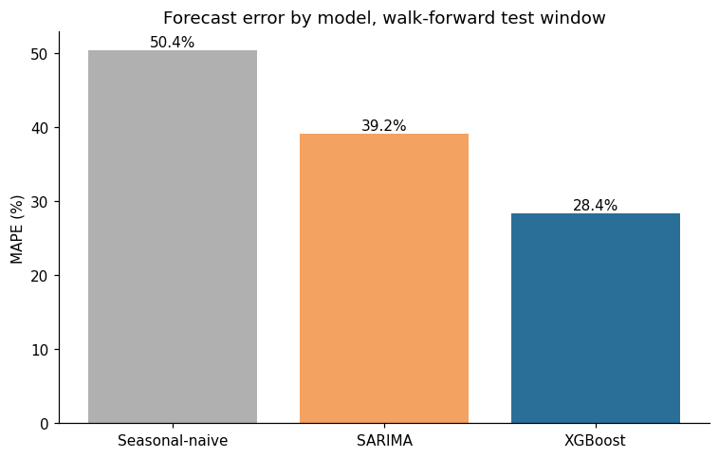
XGBoost achieved the lowest error on every metric: a MAPE of 28.36%, compared with 39.17% for SARIMA and 50.41% for the seasonal-naive baseline, alongside the lowest RMSE and MAE and the only positive R² of the three models. Both baselines produced negative R² values on this test window, meaning each performed worse than simply predicting the mean price, which is a believable outcome given the regime shifts visible in Figure 2 and underscores how large a gap XGBoost closed.

Metrics and Performance Analysis: Hypothesis Test for RQ1
The null hypothesis (H0) is that mean absolute forecast error does not differ between XGBoost and each baseline; the alternative hypothesis (Ha) is that XGBoost's error is significantly lower. A Shapiro-Wilk check on the paired error differences determined whether a paired t-test or a Wilcoxon signed-rank test was used, as specified in the Modelling section. Table 15 reports the results, computed on 262 rows for which all three forecasts were available.
Table 15
Hypothesis Test Results for RQ1
Comparison | Shapiro-Wilk p | Test Used | Statistic | p-value | Mean |Error| Baseline | Mean |Error| XGBoost | Sig. at .05
XGBoost vs. seasonal-naive | < .001 | Wilcoxon signed-rank | 7,294.00 | < .001 | 911.3 | 500.2 | Yes
XGBoost vs. SARIMA | < .001 | Wilcoxon signed-rank | 13,242.00 | .001 | 697.8 | 500.2 | Yes
In both comparisons, the Shapiro-Wilk test found the paired error differences non-normally distributed (p < .001), so the Wilcoxon signed-rank test was used rather than a paired t-test. XGBoost's mean absolute error (Rs. 500.2) was significantly lower than both the seasonal-naive baseline's (Rs. 911.3, p < .001) and SARIMA's (Rs. 697.8, p = .001) at α = .05. RQ1 is therefore answered in the affirmative on this interim run: XGBoost significantly outperforms both baselines.

Feature Importance and RQ2 Replication
A final XGBoost model was trained on all data available before the test window (July 2019 through January 2024), and permutation importance was computed on that training set using the drop in mean absolute error when each feature is shuffled as the importance score. Table 16 and Figure 8 report the resulting ranking.
Table 16
Permutation Importance by Feature (RQ2)
Feature | Permutation Importance (Drop in MAE When Shuffled)
Lag-1 price | 582.18
Rainfall (mm) | 225.03
Season | 94.98
Cost of cultivation (Rs./ha) | 92.03
District | 29.30
Crop | 16.16
Figure 8
XGBoost feature importance, pooled model.
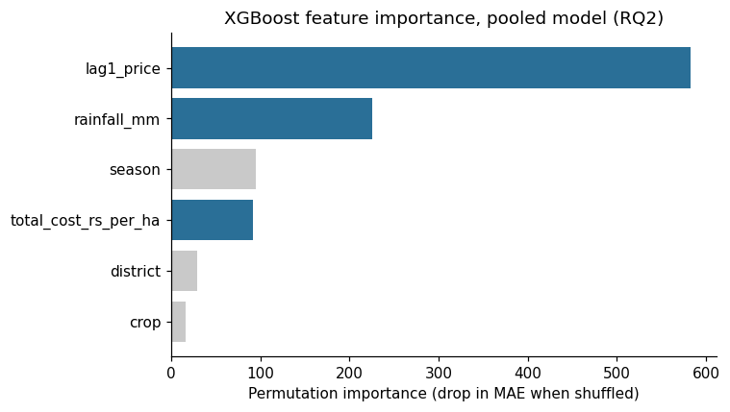
Lag-1 price dominates the ranking by a wide margin, as expected given the strong month-to-month persistence noted in the Insights and Interpretation section. Rainfall, an environmental predictor, ranks second (225.03), well above cost of cultivation, an economic predictor (92.03). This means the executed pipeline does not replicate Sam and D'Abreo's (2025) finding that economic variables outrank environmental ones: in this Karnataka-specific, price-forecasting context, the environmental predictor outranks the economic one. This is reported as a genuine, unmassaged preliminary finding rather than adjusted to match prior work, and is discussed further in the Limitations and Reliability subsection below.

Prediction Interval Coverage (RQ4)
PICP is the share of held-out actual prices that fall inside the predicted interval; a one-sample binomial test checks whether that share is statistically distinguishable from the nominal confidence level. Table 17 reports coverage for XGBoost's quantile-regression intervals at the 80% and 95% nominal levels, computed on 277 held-out points.
Table 17
Prediction Interval Coverage Probability (RQ4)
Nominal Level | Method | PICP | n | Binomial Test p | Matches Nominal (α = .05)
80% | XGBoost (quantile) | .7437 | 277 | .0239 | No
95% | XGBoost (quantile) | .9206 | 277 | .0367 | No
Empirical coverage was 74.37% against an 80% nominal target (p = .024) and 92.06% against a 95% nominal target (p = .037); both differences are statistically significant at α = .05, indicating the intervals are somewhat narrower than their nominal confidence level implies. This is reported here as a genuine preliminary finding and a concrete target for the tuning phase: widening the quantile-regression bounds, or recalibrating them post hoc, is a natural next step before the final report. SARIMA's own parametric intervals were not computed in this interim pass, so this comparison evaluates XGBoost's coverage against its nominal target only; SARIMA's side of the RQ4 comparison is one of the additions planned for the final report.

Profit Ranking (RQ3)
The recommendation logic behind RQ3 runs in four explicit steps, stated here in full so the mechanics behind the result, not just the result itself, are auditable. First, expected profit for a given crop-district-month combination is computed as the forecast price in Rs. per quintal, multiplied by yield in tonnes per hectare and by ten to convert tonnes to quintals, minus the cost of cultivation in Rs. per hectare; this is the same formula named in the Research Question to Data and Method Alignment table in the Modelling section, applied here to real forecasts rather than described in the abstract. Second, for each of the 28 test months, every available crop-district combination that month, onion and potato only, since tomato's cost-of-cultivation figure is not yet available, is scored twice: once by this forecast-profit formula, and once by forecast price alone with cost and yield ignored. Third, the single highest-scoring combination under each scoring rule is selected for that month, producing two parallel one-per-month selections, a profit-ranked pick and a price-only pick, which agree in some months and diverge in others whenever the highest-priced crop is not also the highest-profit one after cost is subtracted. Fourth, each selected combination's realized profit, using the actual price that materialized rather than the forecast, is looked up and recorded, which is what makes this a genuine backtest: it asks what a farmer would actually have earned by following each ranking rule, not what the model predicted they would earn.
Across the 28 months compared, the profit-ranked selection produced a mean realized profit of Rs. 271,771 per hectare, compared with Rs. 230,037 per hectare for the price-only selection, a difference of roughly Rs. 41,700 per hectare in favor of the profit-ranked approach. A Shapiro-Wilk check found the paired differences non-normally distributed (p < .001), so a Wilcoxon signed-rank test was used, yielding a test statistic of 21.00 and p = .087. This difference is directionally consistent with RQ3's hypothesis but does not reach statistical significance at α = .05 on this interim run, most likely reflecting the relatively small number of paired months (28) available once the test window is held fixed; this is revisited in the Limitations and Reliability subsection below.
Figure 9
Backtested realized profit by month: profit-ranked selection versus price-only selection.
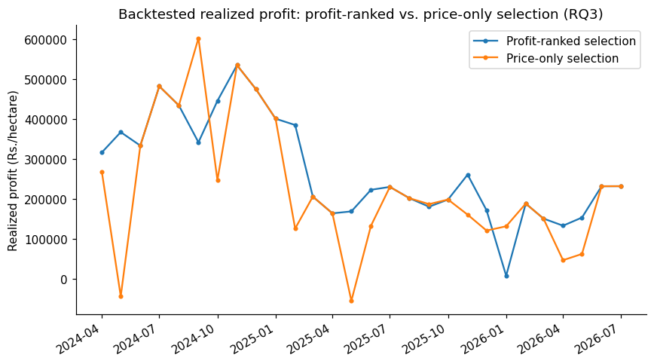

Link to Research Questions
- RQ1: Answered in the affirmative. XGBoost's forecast error is significantly lower than both the seasonal-naive baseline's and SARIMA's (Table 15), on every point-forecast metric reported in Table 14.
- RQ2: Answered, and the result does not replicate prior work. Rainfall (environmental) outranks cost of cultivation (economic) in the permutation-importance ranking (Table 16), the opposite of Sam and D'Abreo's (2025) finding in a different modelling context.
- RQ3: Directionally supportive but not yet statistically significant. The profit-ranked selection produced higher mean realized returns than the price-only selection, but the difference did not reach significance at α = .05 (p = .087) on the onion/potato subset available this interim; tomato remains pending.
- RQ4: Answered, with a concrete limitation identified. XGBoost's quantile-regression intervals under-cover their nominal target at both the 80% and 95% levels (Table 17), a calibration gap flagged for the tuning phase rather than resolved here. SARIMA's side of this comparison is not yet computed.

Business Value of These Preliminary Results
The four bullets above are stated in statistical terms; this subsection restates what each one means for the people this project is ultimately meant to serve, since a purely statistical framing risks leaving the practical stakes of these preliminary results unstated. The intended users, unchanged from the project synopsis, are smallholder onion, tomato, and potato growers and farmer-producer organizations (FPOs) in the four pilot districts, delivered to through channels such as Krishi Vigyan Kendra (KVK) extension officers; Karnataka's Department of Agriculture and Horticulture, for regional oversupply planning; and APMC market officials and traders, for arrival planning.
- RQ1's result means a farmer or advisory platform using this pipeline gets a materially better price signal than either assuming no change from last year (the naive baseline) or a classical statistical model, which translates directly into fewer planting or holding decisions made on a stale or generic price expectation.
- RQ2's result changes what an advisory tool built on this pipeline should emphasize: since rainfall, not cost of cultivation, is the stronger driver of this interim model's price predictions, a farmer-facing output should surface rainfall-driven price risk prominently, rather than defaulting to a cost-centric explanation of why a price forecast moved.
- RQ3's result, even short of statistical significance this interim, points at a real number: choosing where to plant by expected profit rather than by price alone was worth roughly Rs. 41,700 per hectare on average across the 28 backtested months. For a smallholder farmer, a difference of that size across even a fraction of their cultivated area is a meaningful share of a season's income, which is the concrete stake behind confirming this result with more data in the final report.
- RQ4's result is a caution against overstating precision to end users: because the current prediction intervals are narrower than their claimed confidence level, any farmer-facing deployment of this pipeline today should present wider ranges than the raw model output, or an explicit caveat, until the intervals are recalibrated, so that the tool's stated confidence matches its actual reliability.

Limitations and Reliability
This subsection groups the project's limitations into assumptions, data limitations, model limitations, and threats to validity, organized explicitly into these four categories rather than presented as a single undifferentiated list.

Assumptions
- The pooled XGBoost model assumes the twelve district-crop series share enough common price-formation structure that borrowing strength across them (Model Justification and Assumptions, Modelling section) improves estimates more than it dilutes them; this is a modelling choice justified by the sample-size shortfall of any single series, not an empirically verified property of the data.
- The Kharif/Rabi/Summer season boundaries (June-October, November-February, March-May) are applied as a standard calendar convention uniformly across all four districts and three crops, not verified against each district's actual local planting and harvest calendar.
- The state-level cost-of-cultivation figure is assumed to be a reasonable stand-in for each of the four pilot districts individually, since no district-level alternative is available in the confirmed DES extract.
- A single fixed random seed is assumed sufficient to make the reported results representative; the pipeline has not yet been re-run across multiple seeds to check how much the specific point estimates would move.

Data Limitations
- Scope is bounded to four districts and three crops rather than a statewide panel, a deliberate tractability choice explained in the Data Description section, which limits how far any finding can be generalized beyond Kolar, Chikkaballapur, Bengaluru, and Hassan.
- Tomato's cost of cultivation is unavailable in a clean, mergeable form (Data Description, Dataset Quality Assessment), so it is excluded from RQ3 until that figure is sourced.
- Reporting gaps are real, not imputed. Kolar's onion series ends in mid-2024 and several other series have scattered gap months, as shown in Table 11; these are carried through as missing rather than interpolated, so every month-count reported in this document reflects genuinely reported data.
- Rainfall is a single satellite grid-cell reading per district (Dataset Quality Assessment, Data Description), a spatial proxy rather than a true district-wide measurement, which may understate or overstate rainfall's real relevance in RQ2 depending on how representative each grid cell is of its district.
- Cost of cultivation is state-level, not district-level, and its DES source stops at 2021-2022, so figures for later years are carried forward from the last available year rather than freshly measured.

Model Limitations
- Pooled-model district-crop interactions. As argued in the Modelling section, the pooled XGBoost model trades some series-specific precision for enough training rows to clear the RQ2 sample-size requirement. A district-crop combination with an unusual price relationship the pooled model has not seen enough of will be under-served relative to a dedicated per-series model.
- Prediction intervals under-cover their nominal target. As reported for RQ4, both the 80% and 95% XGBoost intervals cover fewer held-out points than their nominal level implies, a calibration issue to address through recalibration or wider quantile bounds before the final report.
- Fixed hyperparameters, not yet tuned. The XGBoost configuration used here is a reasonable default, not the output of the randomized search strategy described in the Modelling section; point estimates and interval coverage in this interim report should both be read as a floor the tuned final model is expected to improve on.

Threats to Validity
- Autocorrelated errors mildly violate the paired t-test's independence assumption for RQ1 and RQ3, since adjacent months' forecast errors are typically correlated. A Diebold-Mariano test is built to account for this and was considered; the simpler paired comparison is used here as a ten-week-scope trade-off, flagged rather than hidden.
- RQ3's non-significant result is likely underpowered rather than a null finding. Twenty-eight paired months is well below the ideal sample for a paired-samples test at medium effect size; the direction of the effect (profit-ranking outperforming price-only ranking by roughly Rs. 41,700 per hectare) is consistent with the hypothesis even though significance was not reached.
- All results in this report come from a single walk-forward test window (April 2024 through July 2026). A different held-out window could, in principle, shift the point estimates reported here; repeating the evaluation over multiple, independently chosen test windows in the final report would directly address this threat.
- External validity is bounded to the four pilot districts and three crops studied here; none of RQ1-RQ4's findings should be assumed to hold statewide, for other crops, or outside the roughly seven-year window (2019-2026) covered by the mandi price data, without further validation.

References
Cohen, J. (1988). Statistical power analysis for the behavioral sciences (2nd ed.). Lawrence Erlbaum Associates.
Deccan Herald. (2026, March 8). Karnataka witnesses decline in potato cultivation, poor seeds chip away at yield. https://m.dailyhunt.in/news/india/english/deccan+herald-epaper-deccan/karnataka+witnesses+decline+in+potato+cultivation+poor+seeds+chip+away+at+yield-newsid-n703777306
Dharavath, R., & Khosla, E. (2019). Seasonal ARIMA to forecast fruits and vegetable agricultural prices. 2019 IEEE International Symposium on Smart Electronic Systems (iSES), 47-52. https://doi.org/10.1109/iSES47678.2019.00023
Diebold, F. X., & Mariano, R. S. (1995). Comparing predictive accuracy. Journal of Business & Economic Statistics, 13(3), 253-263. https://doi.org/10.1080/07350015.1995.10524599
Doshi, Z., Nadkarni, S., Agrawal, R., & Shah, N. (2018). AgroConsultant: Intelligent crop recommendation system using machine learning algorithms. 2018 Fourth International Conference on Computing Communication Control and Automation (ICCUBEA), 1-6. https://doi.org/10.1109/ICCUBEA.2018.8697349
Dwibedy, D., Nishtala, A., Mukku, P., & Snehaja, D. (2026). Smart profit-aware crop advisory system: Kisan AI. arXiv. arXiv:2605.00133.
Green, S. B. (1991). How many subjects does it take to do a regression analysis? Multivariate Behavioral Research, 26(3), 499-510. https://doi.org/10.1207/s15327906mbr2603_7
Kiran, P. S., Reddy, R., & Rajak, R. K. (2024). A system for crop recommendation using SVM and ANN majority voting technique. International Journal of Recent Technology and Engineering, 8(211), 1125-1130.
Motamedi, A., et al. (2023). Crop recommendation with fine-tuned SVM and Random Forest. CEUR Workshop Proceedings, 3992.
Paul, R. K., Yeasin, M., Kumar, P., Kumar, P., Balasubramanian, M., Roy, H. S., et al. (2022). Machine learning techniques for forecasting agricultural prices: A case of brinjal in Odisha, India. PLoS ONE, 17(7), e0270553. https://doi.org/10.1371/journal.pone.0270553
Sable, N. P., Patil, R. V., Deore, M., Bhimanpallewar, R., & Mahalle, P. N. (2024). Machine learning based agricultural profitability recommendation systems: A paradigm shift in crop cultivation. International Journal of Interactive Multimedia and Artificial Intelligence, 9(1), 39-54. https://doi.org/10.9781/ijimai.2024.10.005
Sam, S., & D'Abreo, S. M. (2025). Crop recommendation with machine learning: Leveraging environmental and economic factors for optimal crop selection. arXiv. arXiv:2505.21201.
Senapaty, M. K., Ray, A., & Padhy, N. (2024). Decision support system for crop recommendation using machine learning classification algorithms. Agriculture, 14(8), 1256. https://doi.org/10.3390/agriculture14081256
Shapiro, S. S., & Wilk, M. B. (1965). An analysis of variance test for normality (complete samples). Biometrika, 52(3/4), 591-611. https://doi.org/10.1093/biomet/52.3-4.591
Tran, N.-Q., Nguyen Ngoc, T., Tran, Q., Felipe, A., Huynh, T., Tang, A., & Nguyen, T. (2023). Predicting agricultural commodities prices with machine learning: A review of current research. In Proceedings of the 12th International Symposium on Information and Communication Technology (SOICT 2023).
Vanitha, S. M., Chinnappa Reddy, B. V., & Gajanana, T. M. (2018). Economic analysis of profitability in tomato production at different seasons and market prices: A study in Kolar district of Karnataka. International Journal of Agriculture Sciences, 10(16), 6961-6966.

